**Application Deployment**

(Deploy the given React application to a production ready state)

**Application:**

Clone the below mentioned repository and deploy the application (Run application in port 3000).

Repo URL : <https://github.com/Vennilavan12/Trend.git>

Github repo cloned:

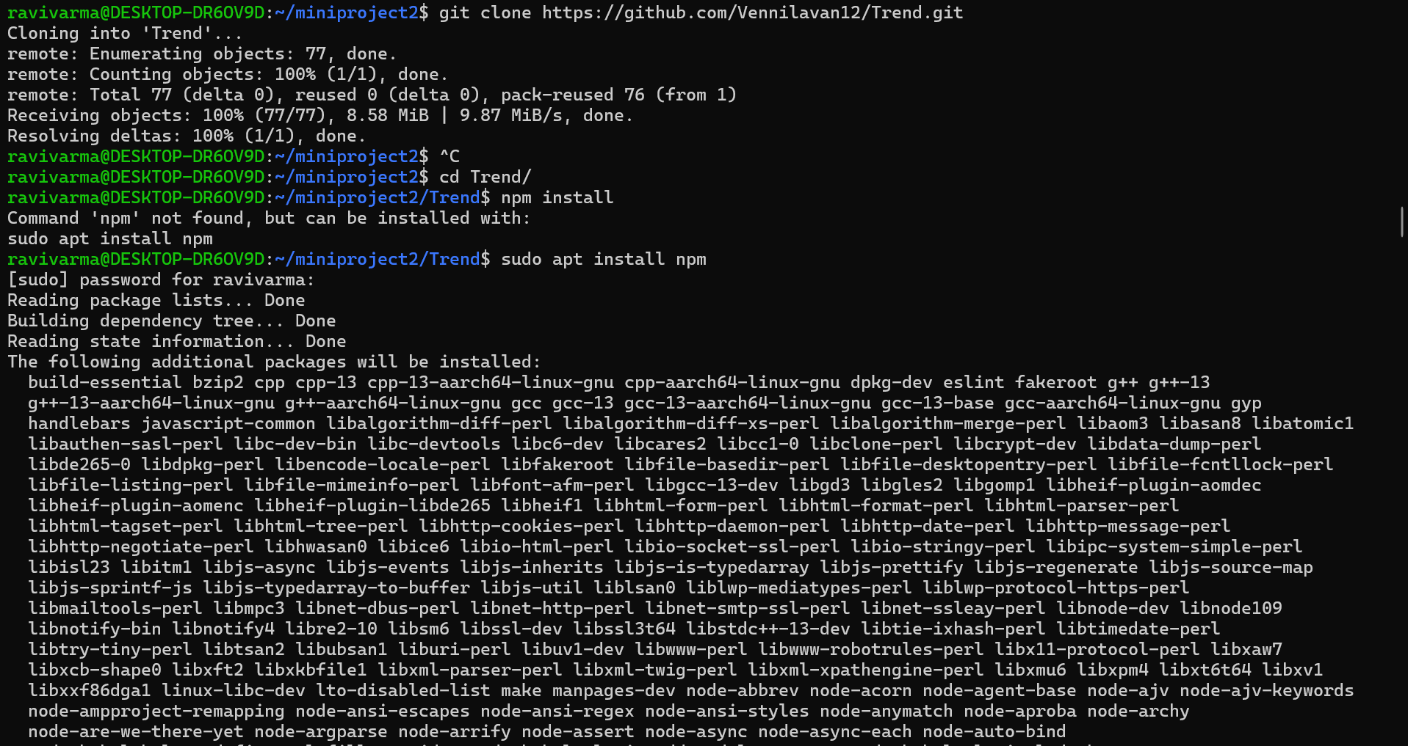

**Docker:**

* Dockerize the application by creating Dockerfile

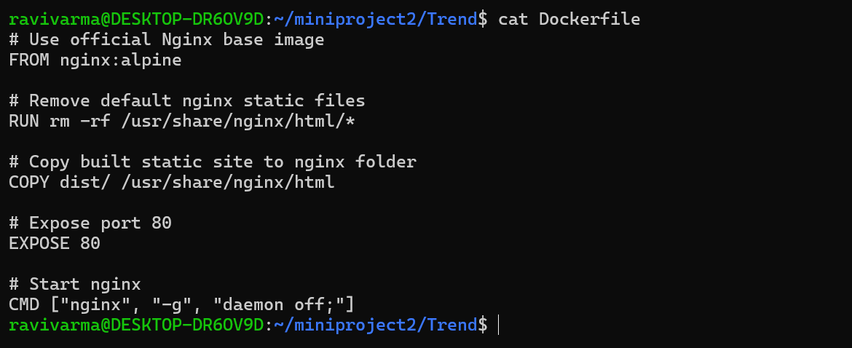

* Build an application and check output using docker image.

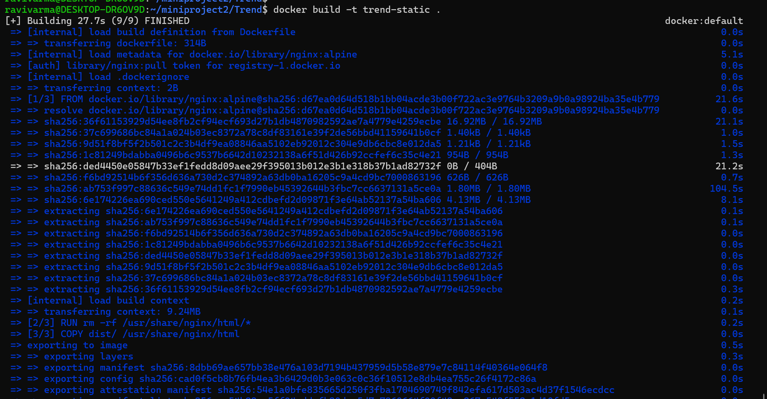

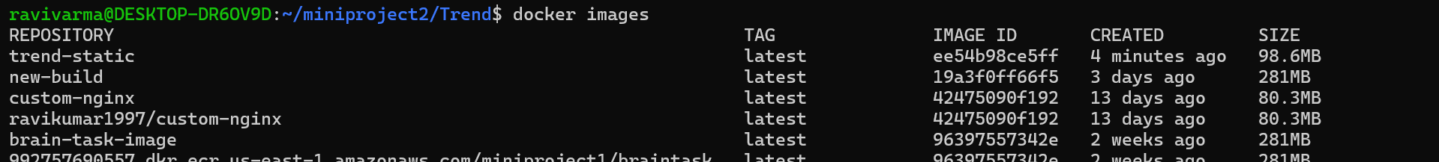

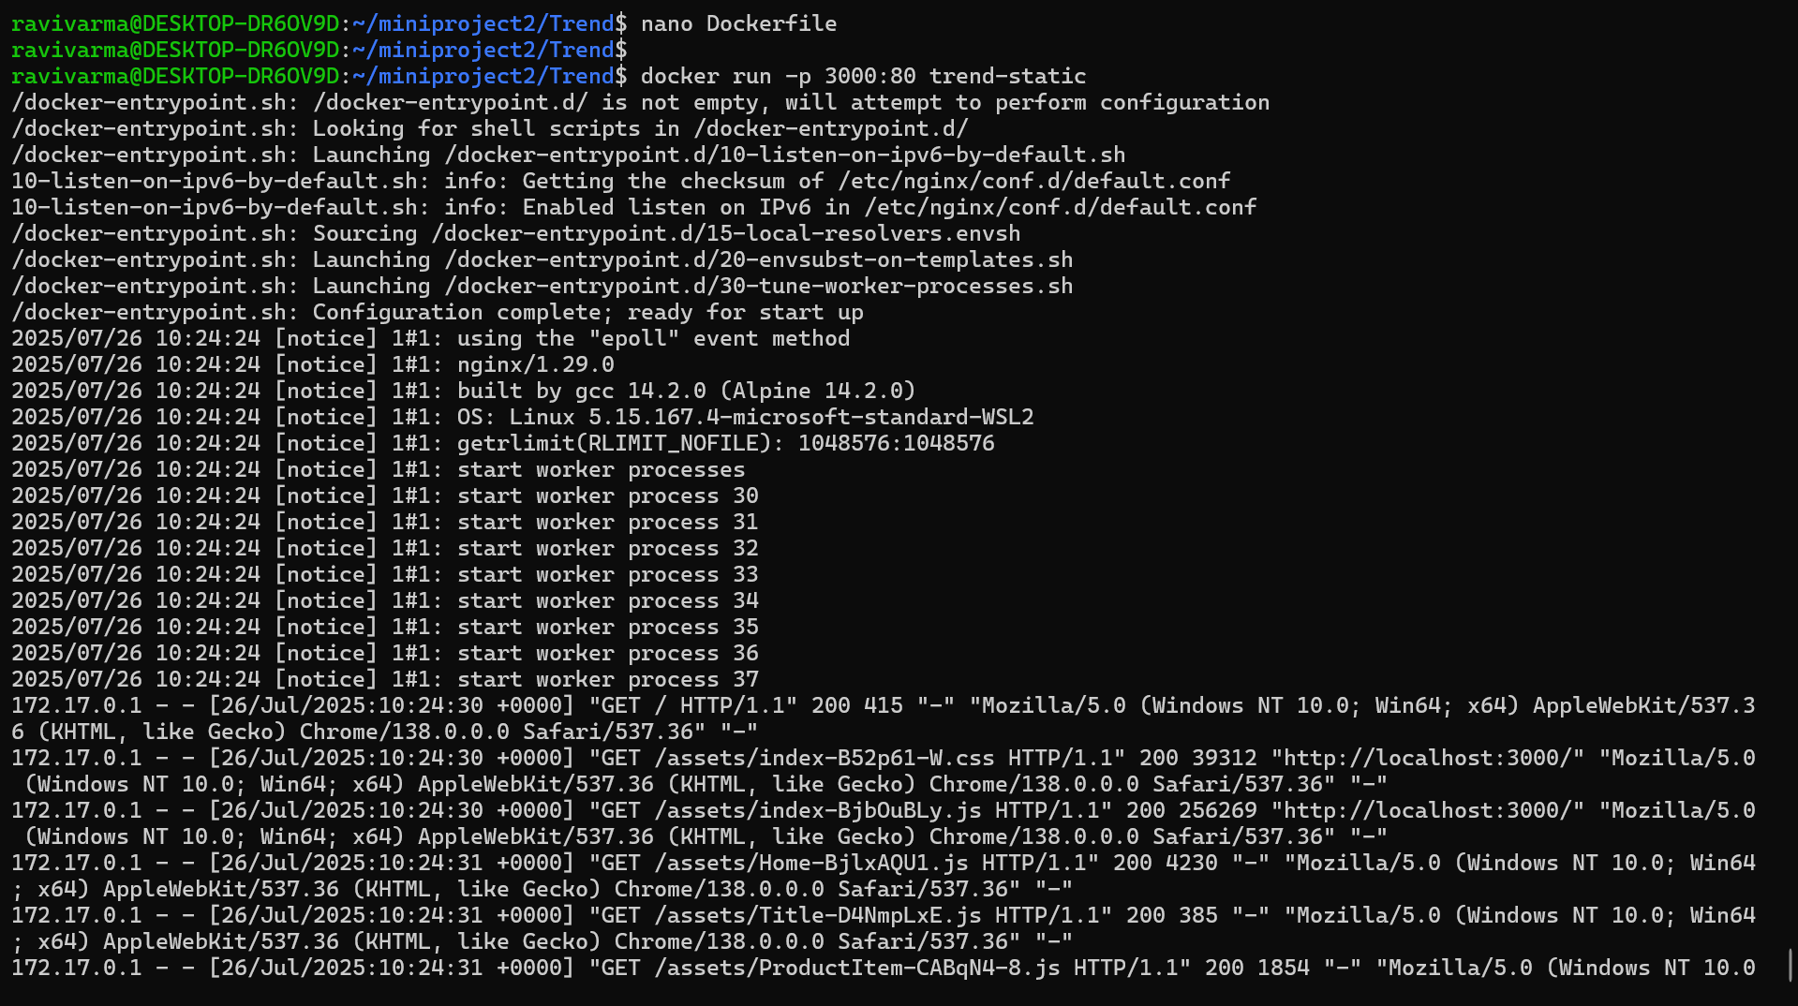



**Terraform:**

* Define infrastructure in main.tf to create VPC, IAM, EC2 with Jenkins, etc.
* Use terraform command to provision infrastructure.

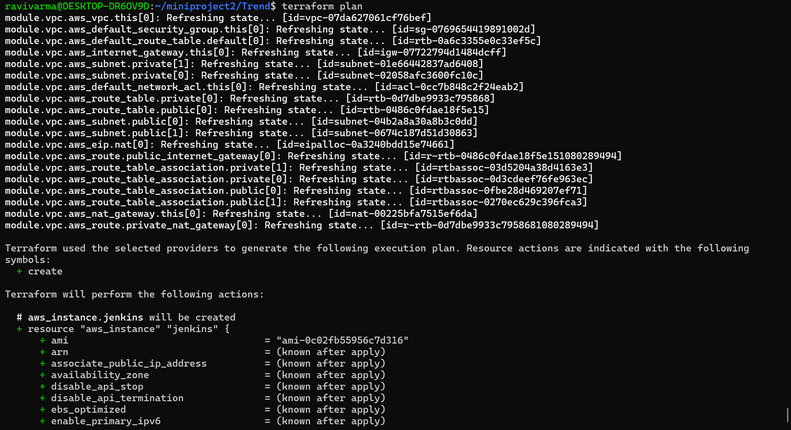

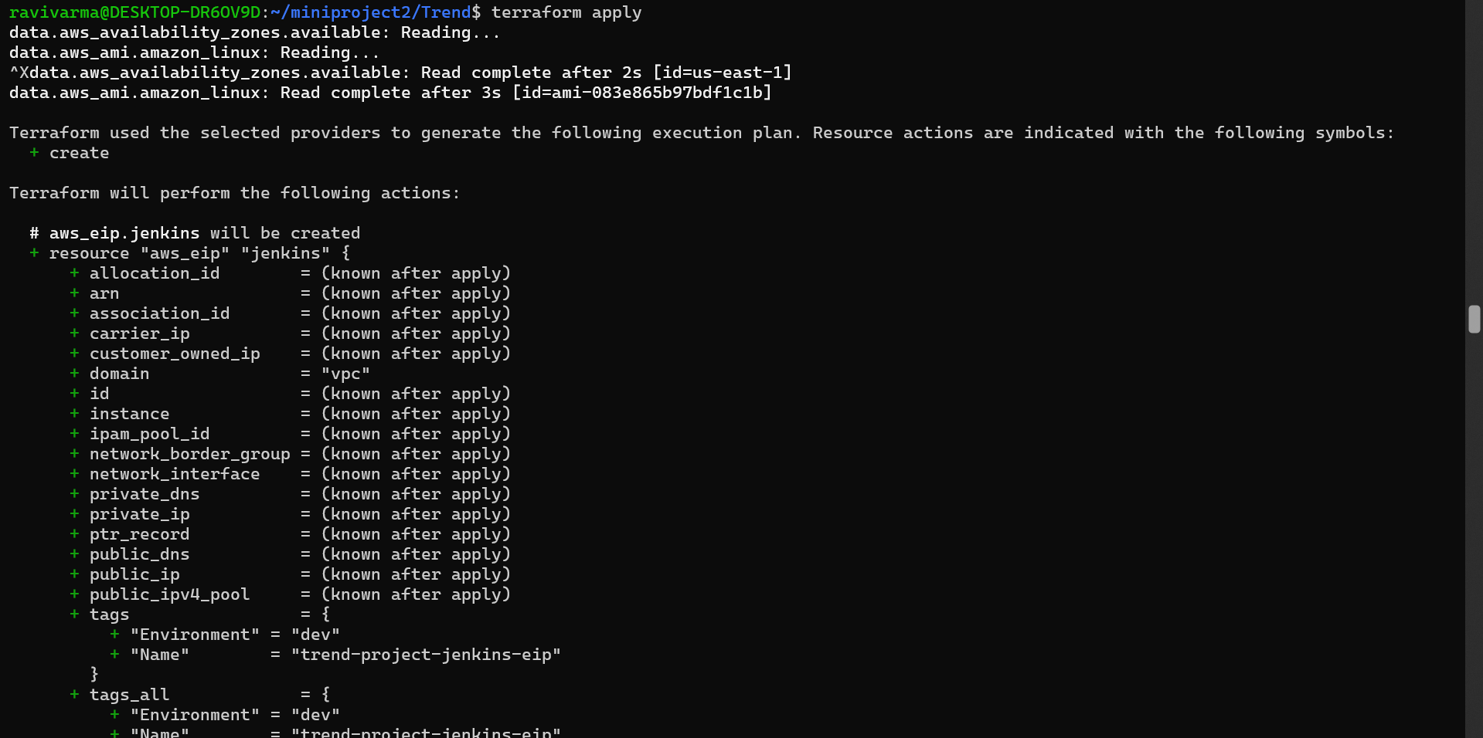

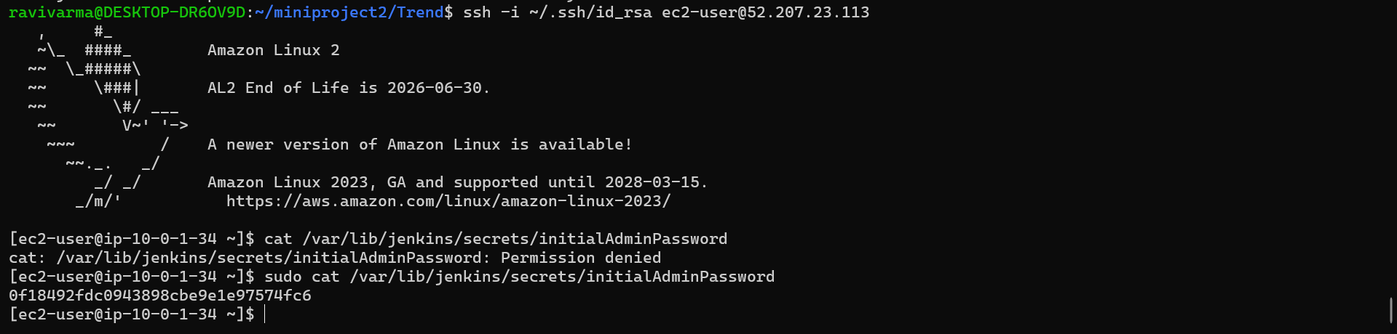

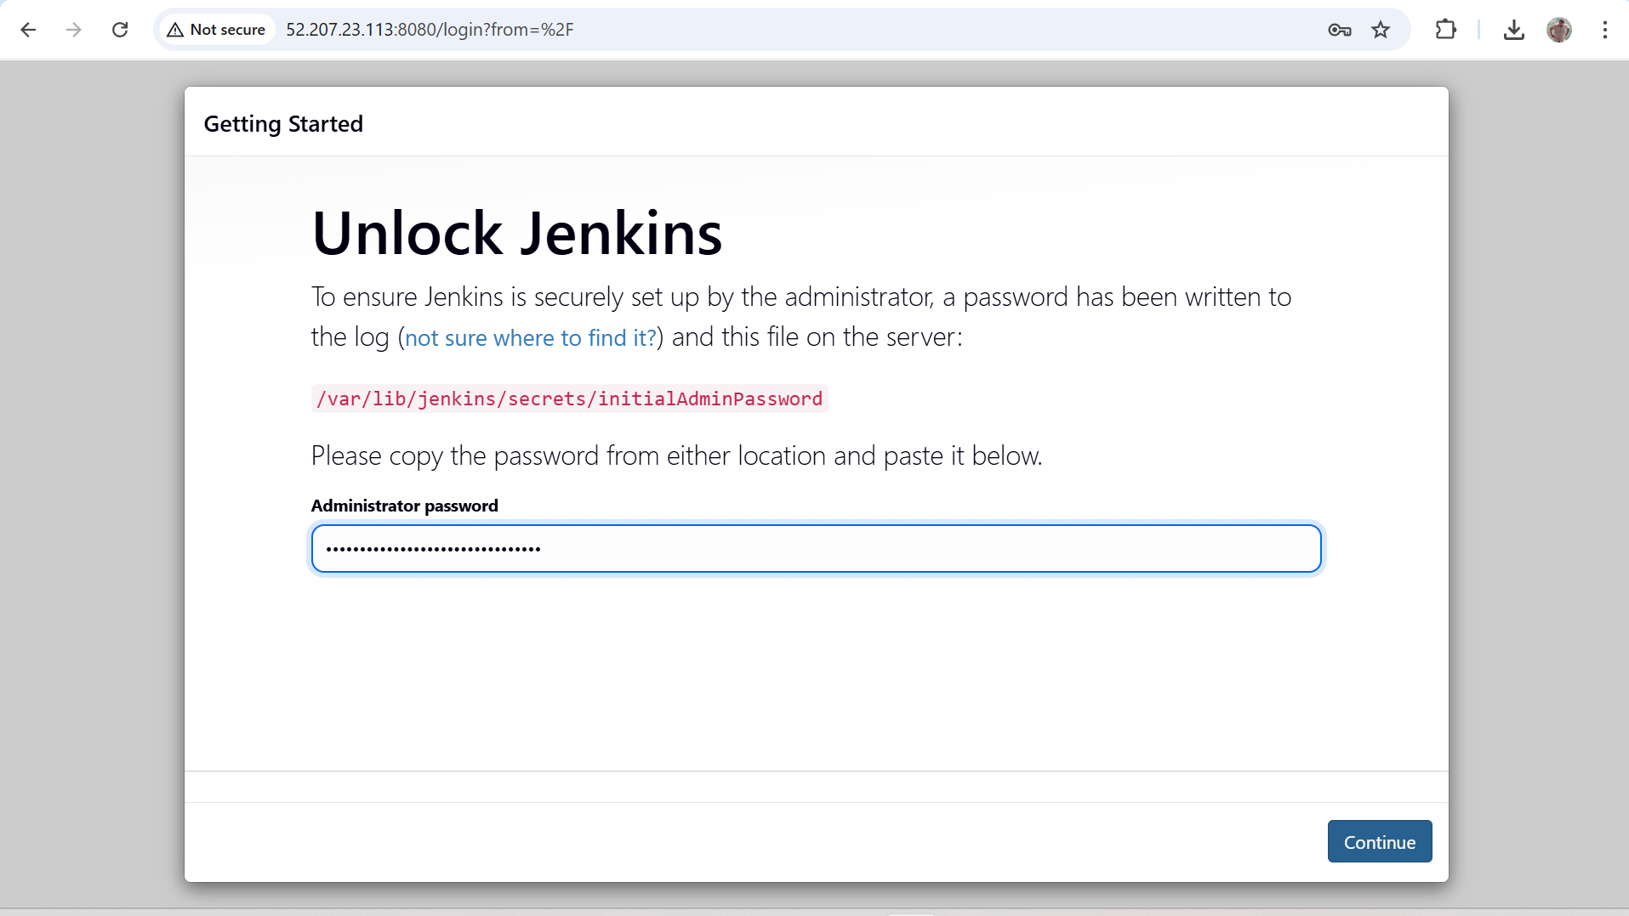

**DockerHub:**

* Create a DockerHub repository.

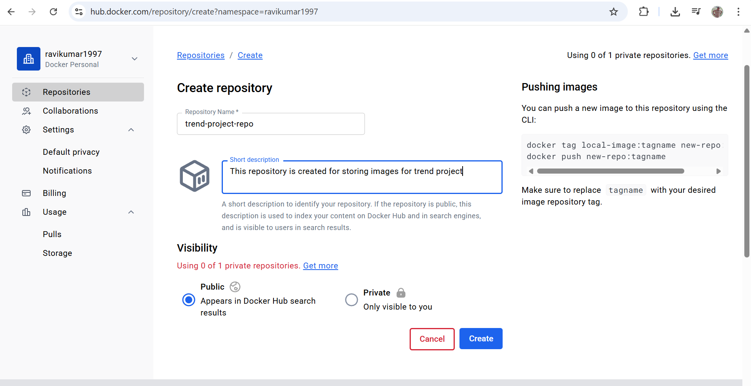

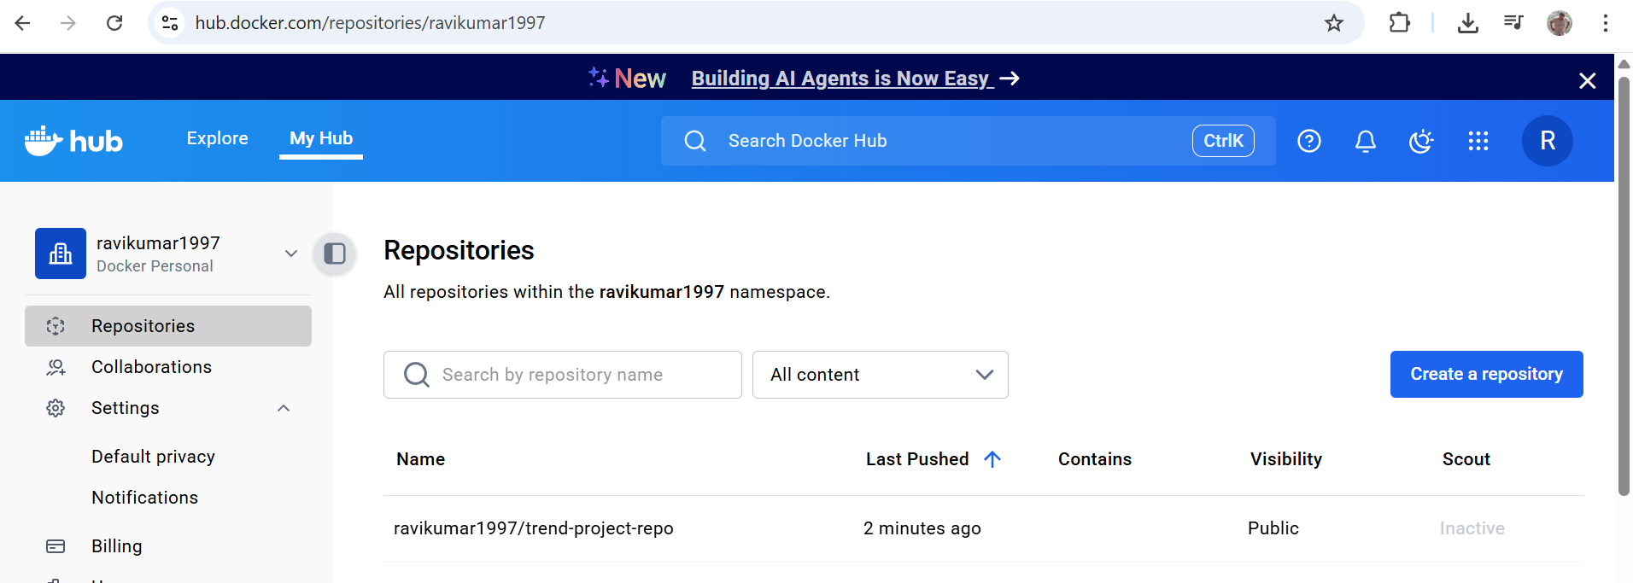

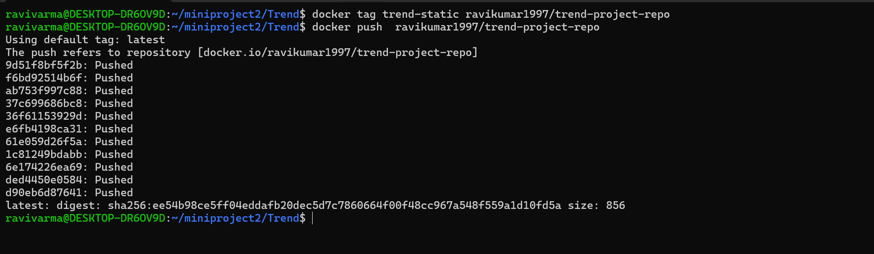

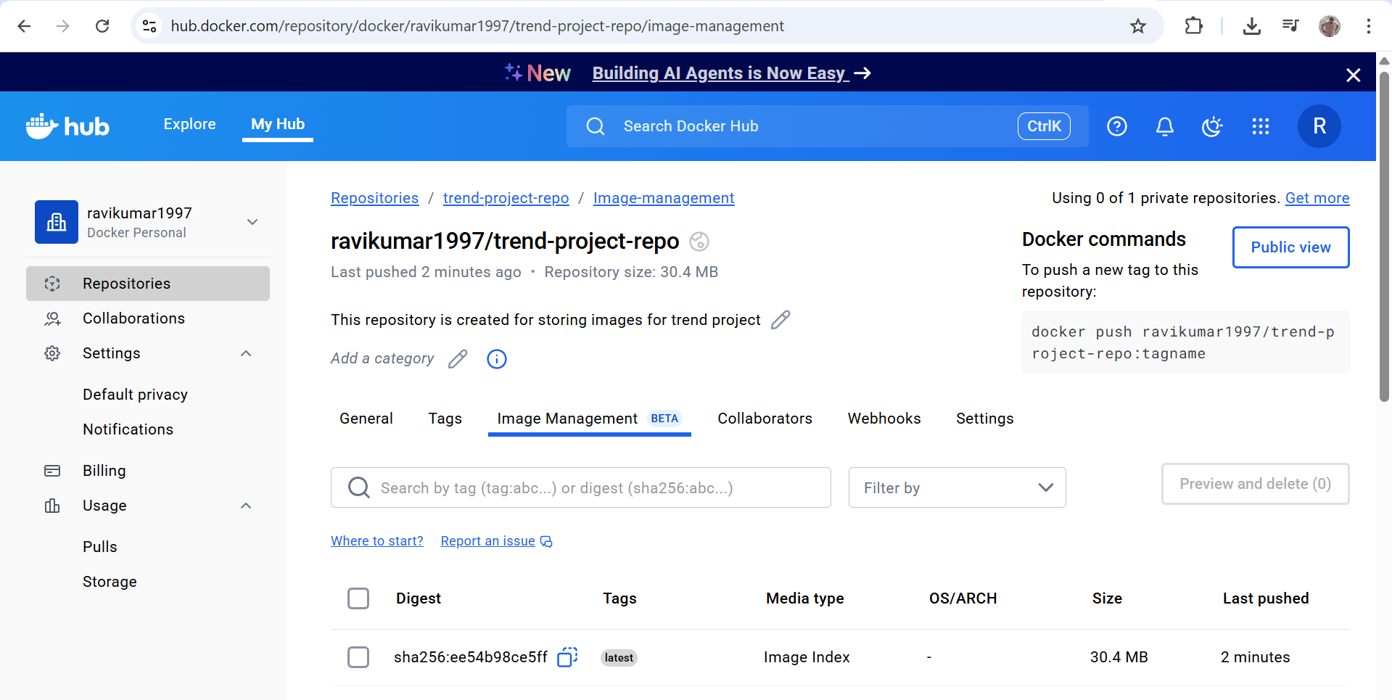

**Kubernetes:**

* Setup Kubernetes in AWS EKS and Confirm EKS cluster is running.

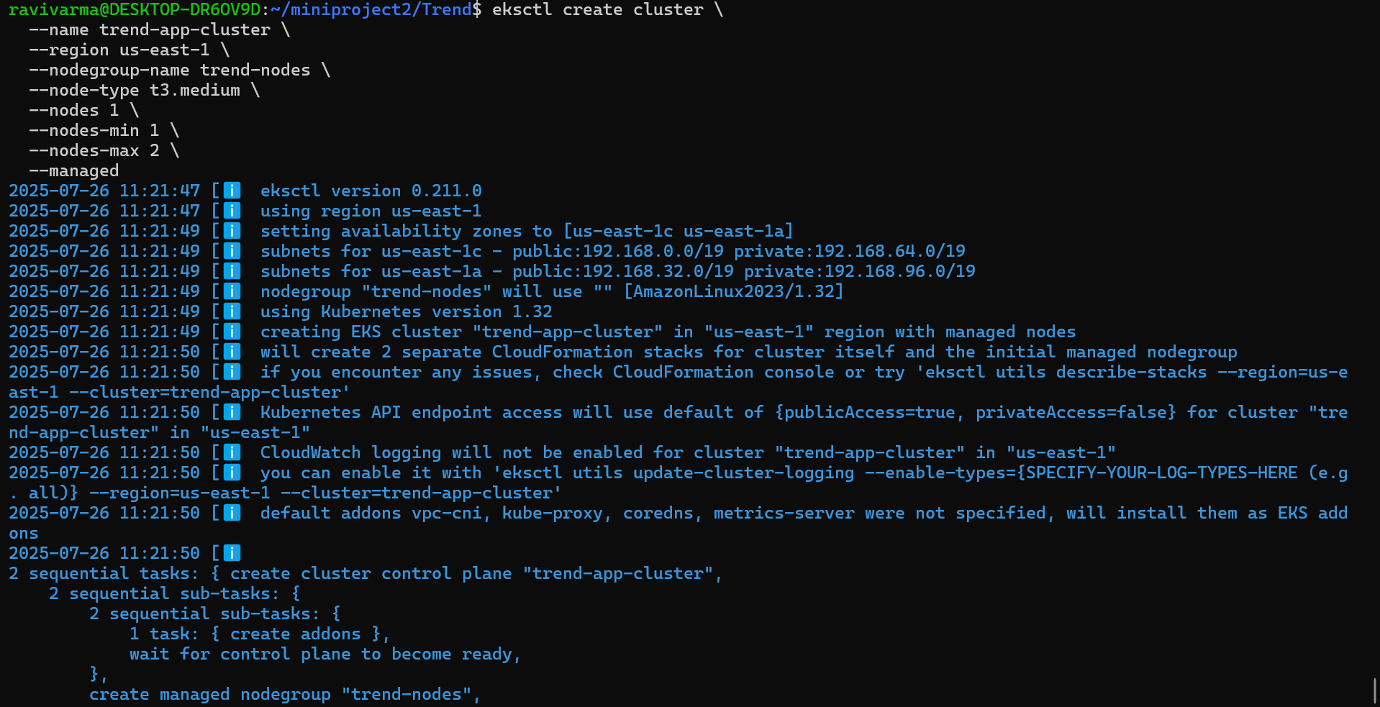

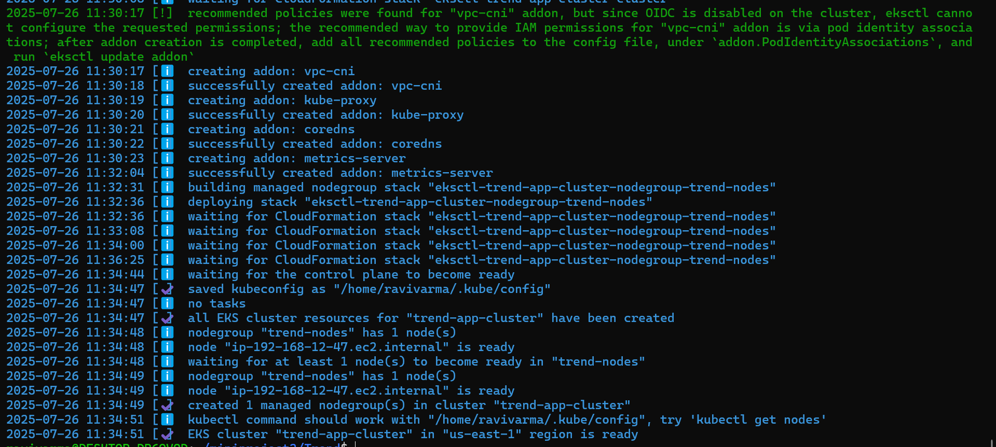

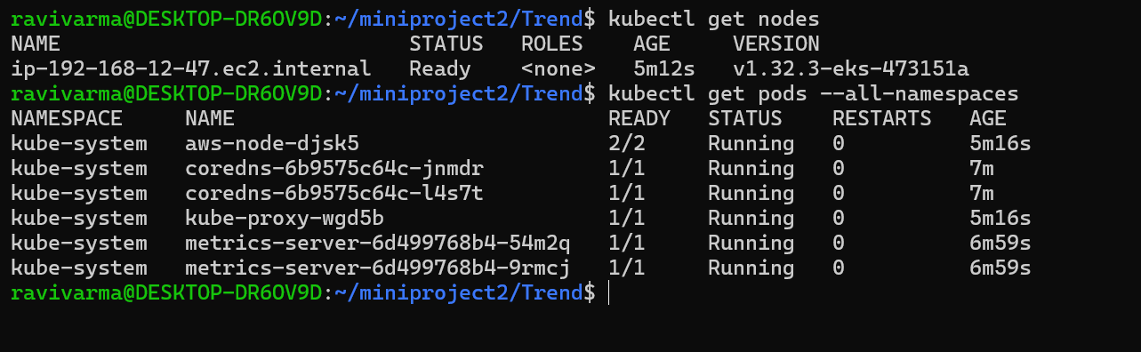

* Write deployment and service YAML files.

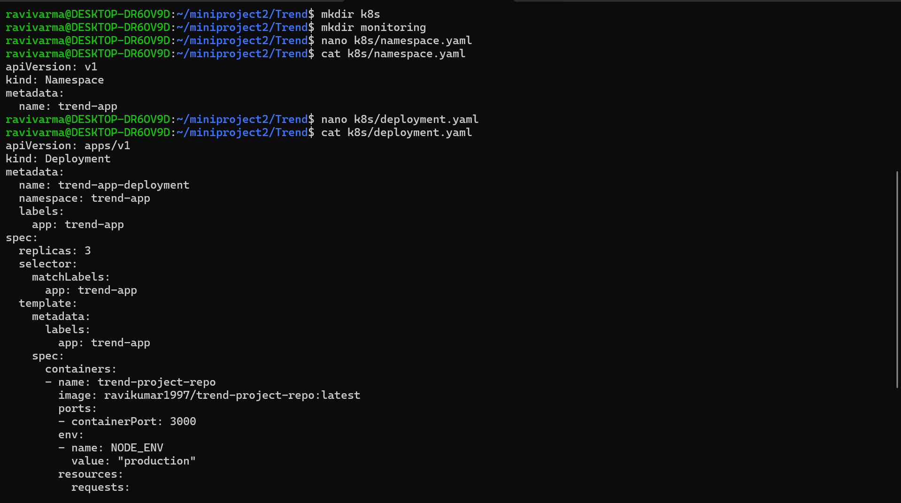

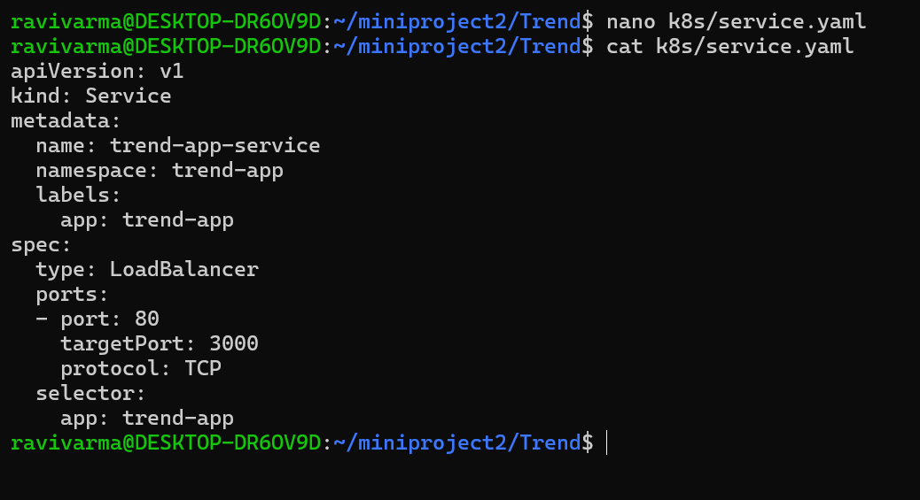

* Deploy using kubectl via Jenkins.

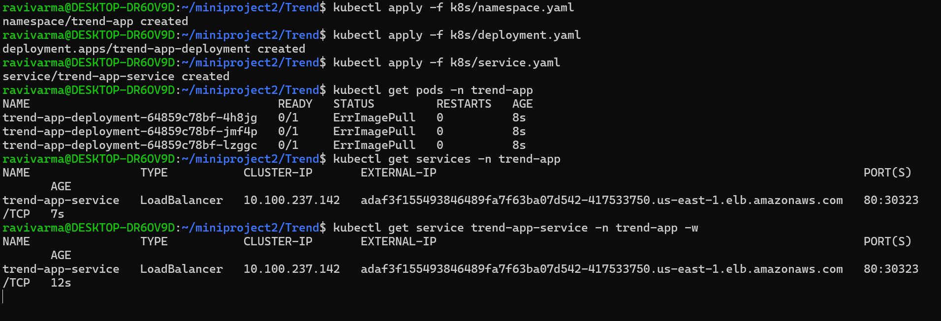

Checking eks accessibilty from jenkins server



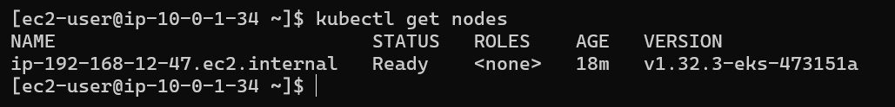

**Version Control:**

* Push the codebase to a Git provider (GitHub).
* Add gitignore and dockerignore files and use CLI commands to push code.

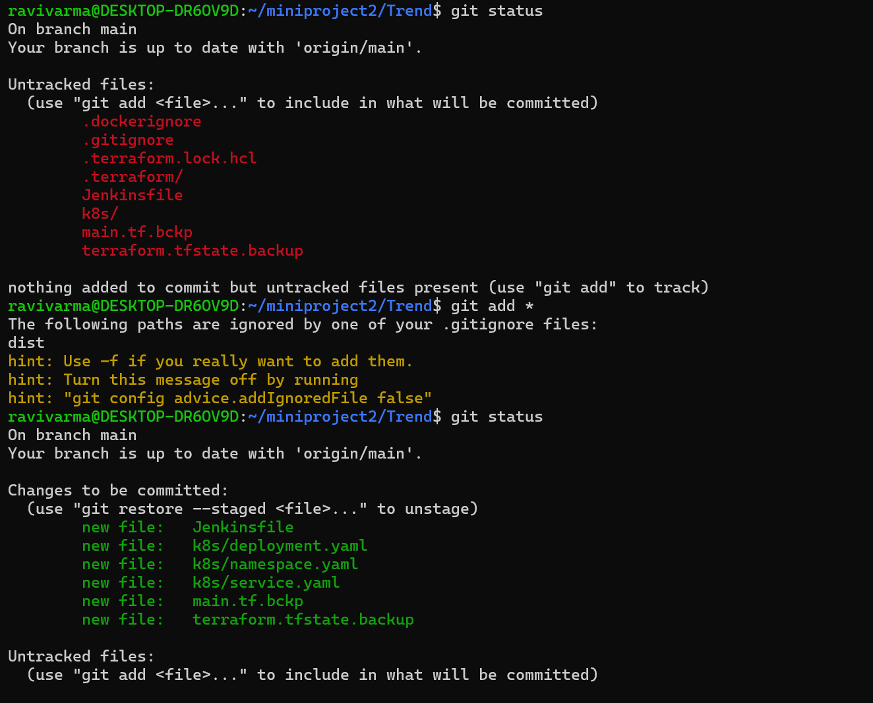

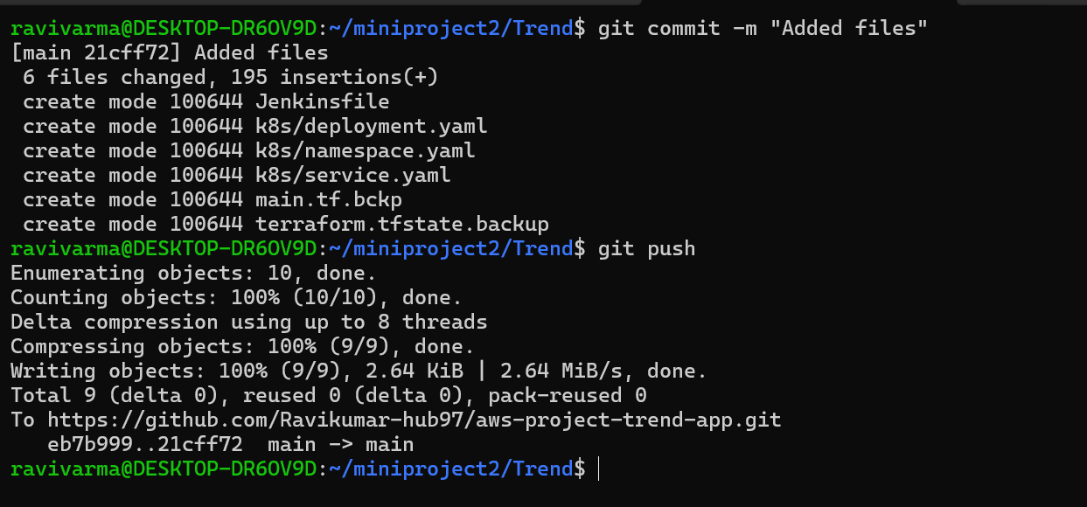

**Jenkins:**

* Install Jenkins and necessary plugins (Docker, Git, Kubernetes, Pipeline) for build, push &deploy applications.

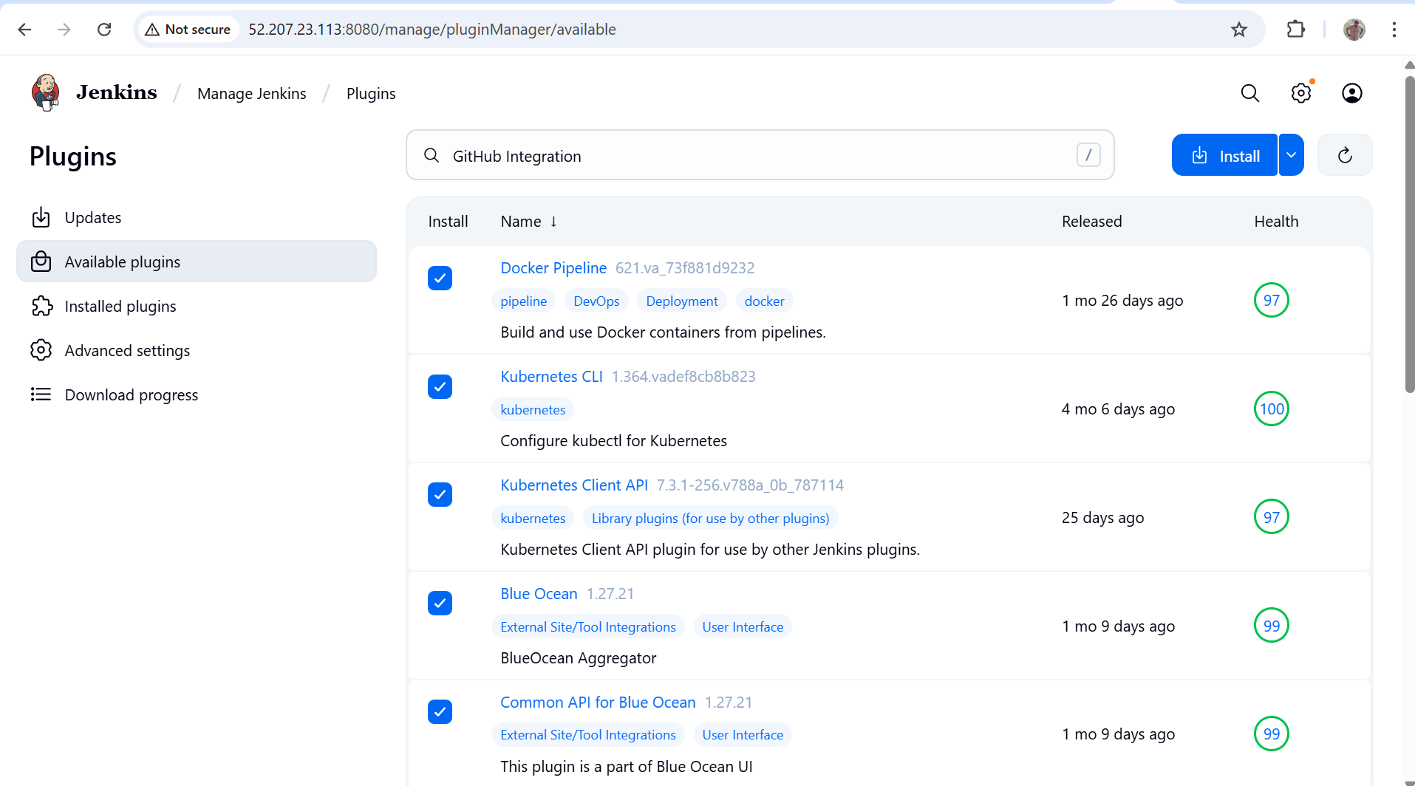

* Setup Github and jenkins integration using github webhook build trigger for auto build for every commit.

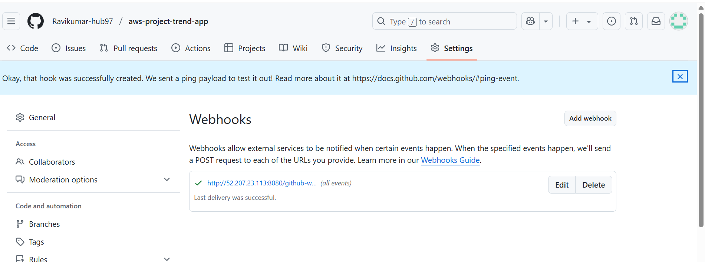

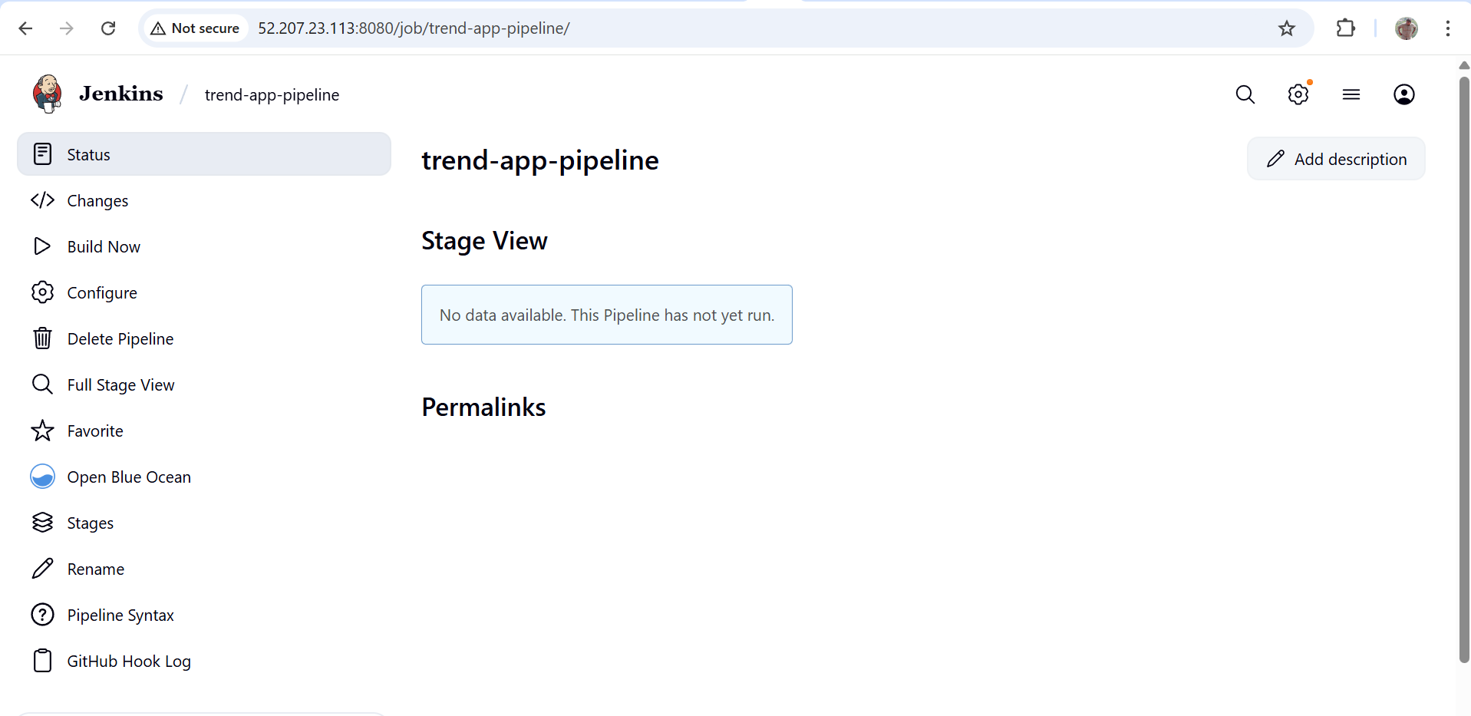

* Create a declarative pipeline script and pipeline project to build, push & deploy using CI-CD.

Testing manual deployment which was done earlier:

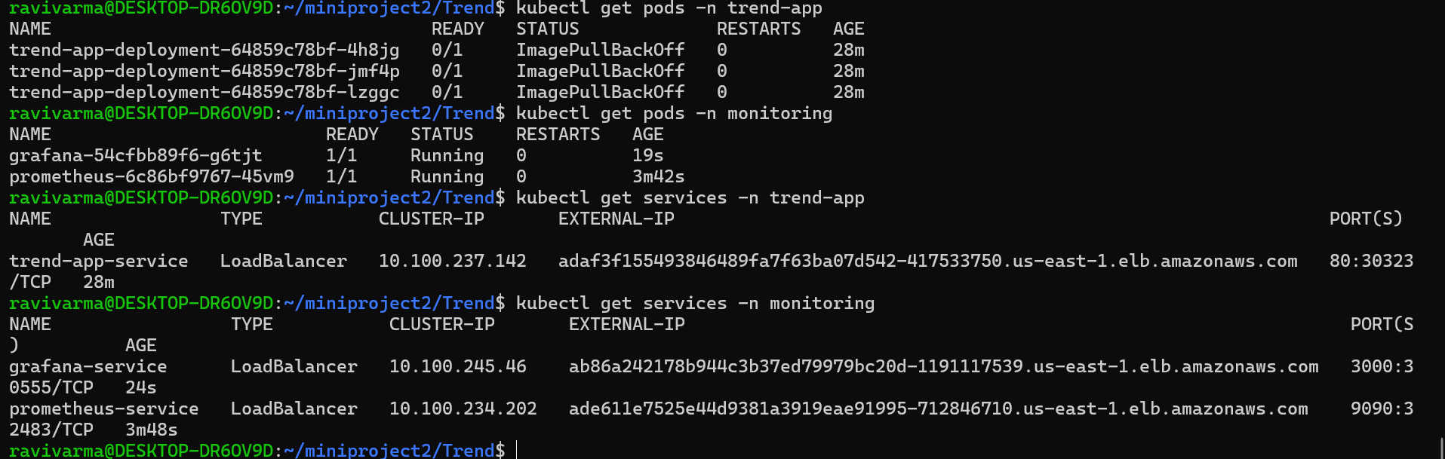

Trigger:

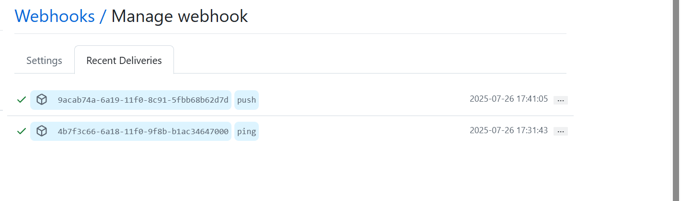

Final verification:

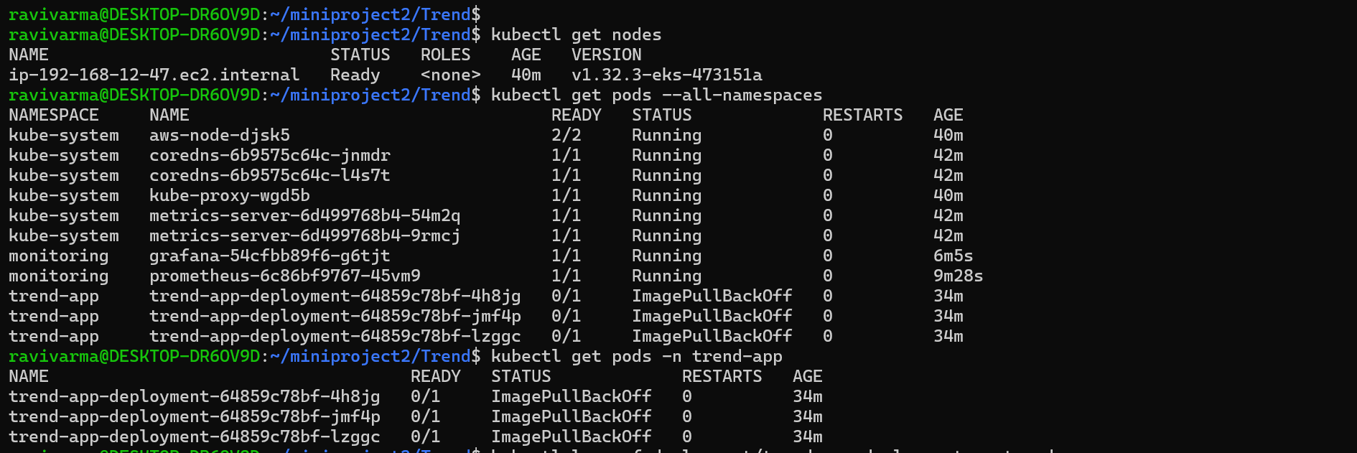

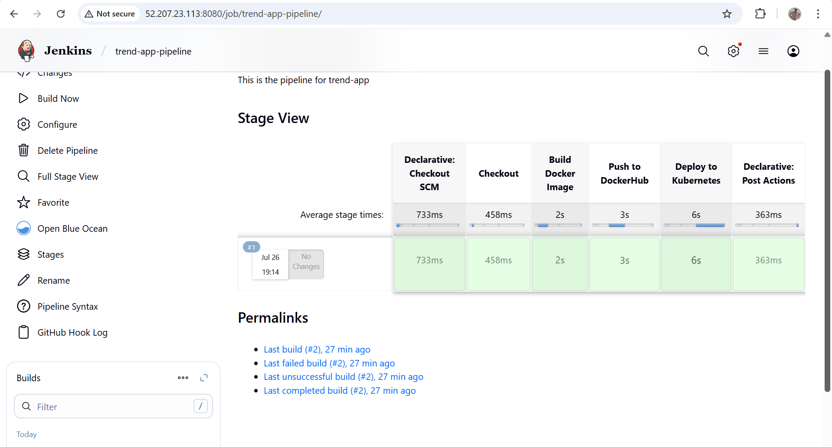

Upon github push triggered, and the pipeline ran



**Monitoring:**

* Setup a monitoring system to check the health of the cluster or application (opensource) is highly appreciable.

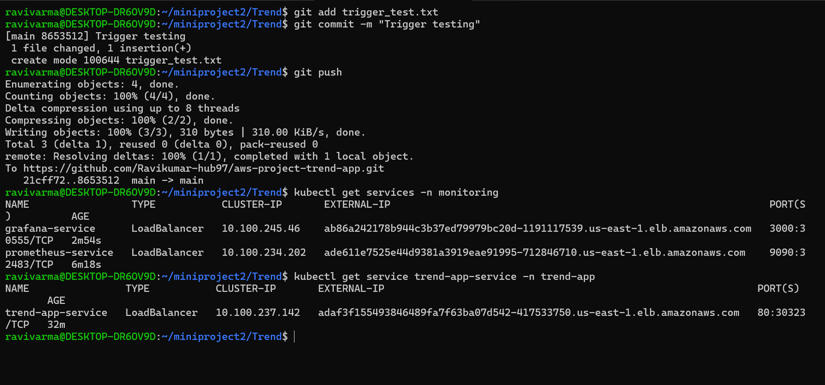

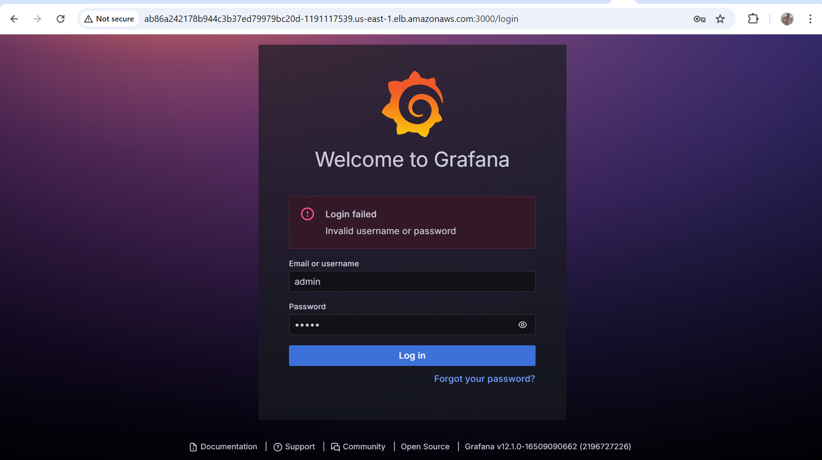

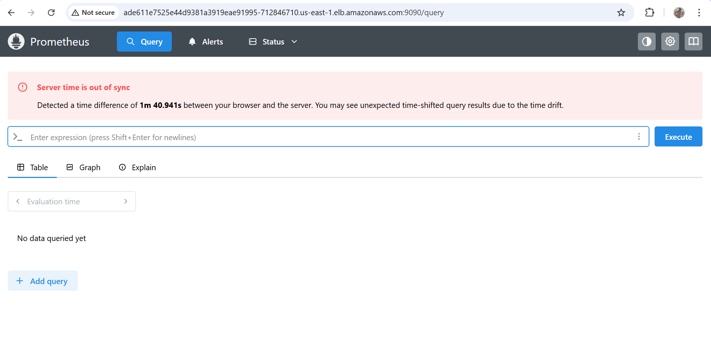

**Submission Guidelines:**

* GitHub Link: Submit full code repository.
* README File: Include setup instructions, pipeline explanation, and screenshots or create a document and attach all screenshots.
* Application deployed kubernetes Loadbalancer ARN.